
a
Company
Logotype

Cone Beam Computed Tomography- Report



Porur Dental X-rays & CBCT

Patient Name : Mrs. Sumathi | Date of Report : 15.05.2024
Age/ Gender : 53 years/ Male | Region of Interest : CBCT Maxilla
Referring doctor: Dr. Suchitra | Indication : Implant assessment
Clinical Notes: Nil
PATIENT INFORMATION

CBCT- Maxilla provided
CBCT – IMAGE DETAILS

RADIOGRAPHIC INTERPRETATION

- Completely missing crown and root portion in relation to 11, 12.
- Presence of hyperdense restorative material within the pulp canals extending upto the apical third of the roots in relation to 12, 13, 21, 22, 23.
- The maxillary alveolar ridge is present with normal trabecular pattern.

IMPLANT ASSESSMENT

 | 11 region | 12 region
Sub-Crestal | 6.3 | 5.28
Mid- Crestal | 6.37 | 5.05
Distance between the alveolar ridge and Floor of the Nasal cavity (in mm) | 15.94 | 16.03

RADIOGRAPHIC IMPRESSION

- Partially edentulous maxillary arch.
- Root canal treated teeth: 13, 14, 21, 22, 23.

Kindly correlate with clinical findings


IMAGES FOR REFERENCE

RECONSTRUCTED PANORAMIC VIEW

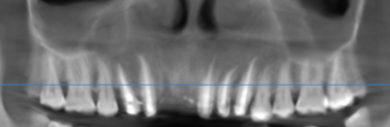

3-DIMENSIONAL VIEW

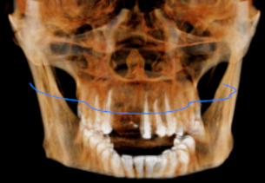

CROSS SECTIONAL VIEW

11 region | 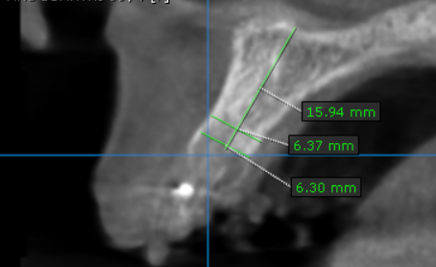
12 region | 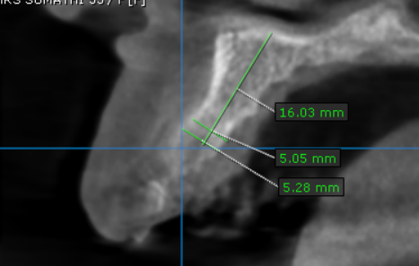

**** End of report ****

